

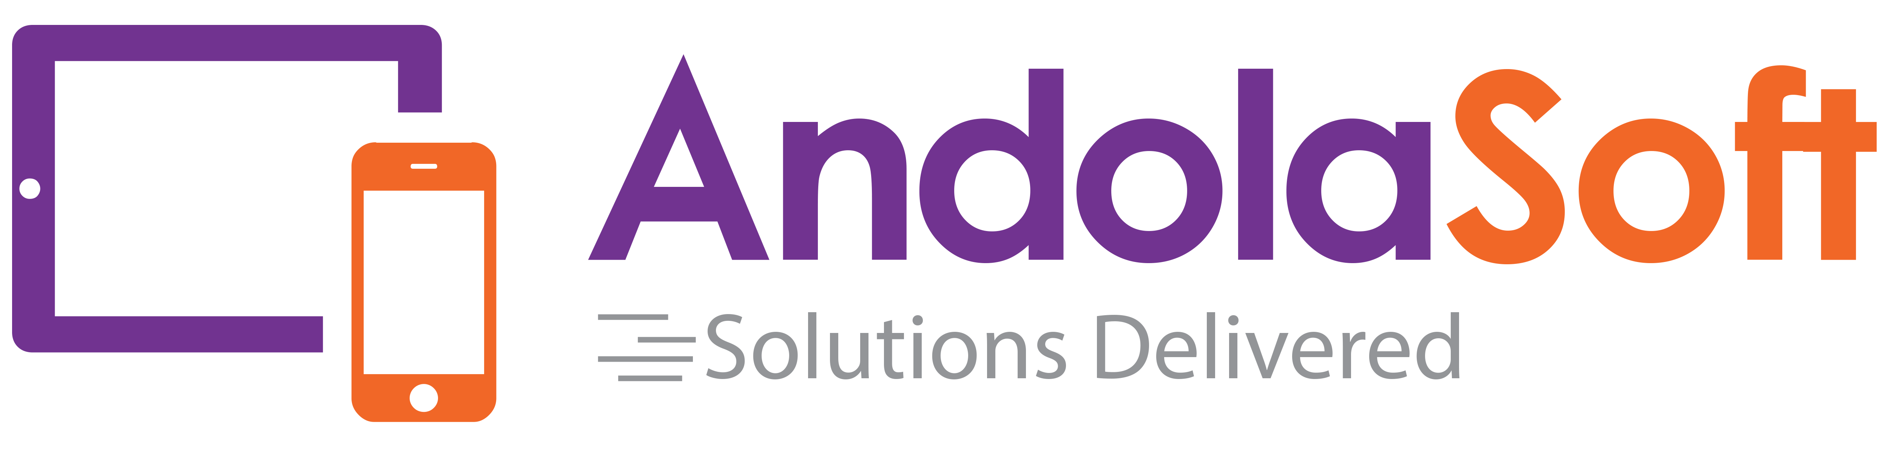

**Proposal and Specification for:**

**Mobile Application Development for CRM-4Beauty**

Presented by

**Andolasoft**

HQ & West Coast  
2059 Camden Ave. #118,

San Jose, CA

95124  
USA

Submitted to:

**Max Rockwell**

CRM-4Beauty

Presented by:

**Anurag Pattnaik**

Manager- Delivery & Business Development

Andolasoft Inc.

*Date:29thJuly, 2016*

Hello,

It is with great pleasure that I present to you our proposal. Having recently developed an in-depth understanding of the CRM-4Beauty company vision, I believe Andolasoft would be an ideal partner to design and develop the Native Mobile application. Our team of expert developers and creative talent are a perfect match to meet the technical and aesthetic vision of CRM-4Beauty.

Our proven track record for projects large and small, including numerous startups, gives us the ability to create a product based on prior successes as well as collective insight.

We appreciate your consideration and confidence. Please contact Mr. Anurag Pattnaik at anurag.pattnaik@andolasoft.com with any questions.

Best Regards,

Anurag Pattnaik

Manager- Delivery & Business Development

[www.AndolaSoft.com](http://www.AndolaSoft.com)

**Executive Summary**

This Business Proposal represents a combination of strategic guidance as well as best practices in user experience design and development for the Mobile application.

Based on the idea of CRM-4Beauty, we understand the goal of our initial engagement is the development of a functioning mobileapplication which will be developed for iOS & Android platform.

**TABLE OF CONTENT**

1 Company Profile 4

2 Case Study – Leaguer mobile application development 5

3 CompanyPortfolio 6

4 Project scope 12

5 Deliverables 12

6 Sample App Screenshots 13

7 Team structure 14

8 Project Timeline& Cost Estimation 14

9 Payment Method and Phases 14

10 Support & maintenance plan for mobile app 14

11 Change Request Process 15

12 Terms & Conditions 15

# Company Profile

**Who we are**

We are a dynamic Web&Mobile development company based in San Jose, CA having development centrein India. We design, develop Web, iPhone, iPad, AndroidApps for start-ups & established businesses. We are agile and do help clients by delivering projects in time and within budget. We believe in quality work done by our experienced resources. We have satisfied customers spread across the USA, Canada, Australia, UK, Singapore& Brazil. Andolasoft awarded as best mobile app Development Company by ***Mashable*** in ***June 2014***.

**What we do**

Andolasoft is providing you the opportunity to move out of your cubicle and use the amazing mobile apps and services developed by us. Our innovative and creative developers understand the requirement of our clients and choose a most optimized beneficial solution and then convert that into a product. We're developing apps featuring maps, store locators, online orders & bookings, social sharing, product or service rating and many others. Currently we're developing apps for iPhone, iPad & Android smartphones.

**Why choose us**

The company values stand on the understanding that our success is tied to the success of our clients. We work closely with our customers to ensure that we meet the service levels on the most CTQ parameters of **'flawlessness'**, '**within budget**' and '**on time'** application development along with strong security measures to safeguard customer data and information.

**Our Strategy**

Our strategy is simple. We stick to an agile process flow, which includes seven critical steps: Unearth >> Design >> Develop >> QA >> Launch >> Measure >> Iterate

# Case Study – Leaguer mobile application development

**Introduction**

This case study illustrates how we created the feature-rich, cross platform mobile app using ionic framework to help our client reach their target audience of mobile users across popular mobile platforms.

**Problem**

Leaguer is already having its own web application. As the web application comes under

League/Sports management industry, so most of the target users are most of the times in the fields/courts/sport’s venues, and they always need to browse the website to make registration, payment, managing schedules and team scores. Additionally, Leaguer was looking for a cross platform mobile app so that the code base will be same and can be easily maintainable at the same time.

**Proposed Solution**

Due to the growth of Smartphone application usages, there was an opportunity for Leaguer to attract Smartphone users looking for league management application. Also the Smartphone application would help the existing users to seamlessly access the core functionalities like managing schedules, team management, registration, cart and make payment inside their Smartphone application without need to browsing the website.

We started our ground work for choosing a best cross platform framework for our client and

proposed ‘Ionic’ which was the best fit as per the requirement. Ionic is having best community support and offering a native looking UI out of the box.

**Challenge**

Client was having limited budget for the mobile application. He was keen to have the mobile

application with no performance issues and very lightweight at the same time.

**Outcome**

Ionic framework, with its impressive suite of polished tools, was selected for building the cross-platform mobile app. Ionic is built to perform and behave great on the latest mobile devices. Andolasoft developed the mobile app and the backend API endpoints which communicates with the Leaguer web platform, completed in 14 weeks of the timeframe. Andolasoft also helped Leaguer to place the smartphone application on the respective market places for iOS, Android.Summarily, the mobile app **increased the user conversion ratio of Leaguer to 40%**.

# CompanyPortfolio

Some of our Recently Developed iPhone/iPad applications

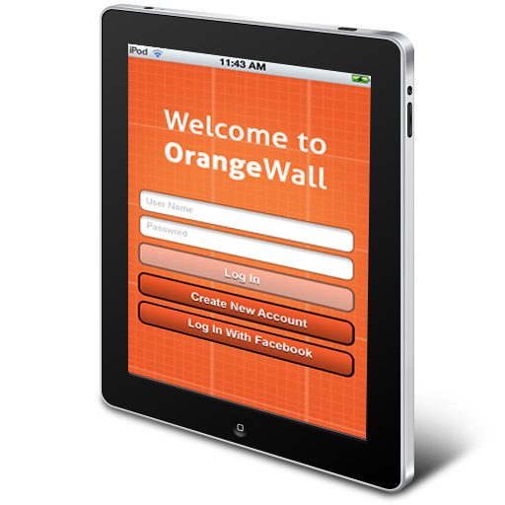

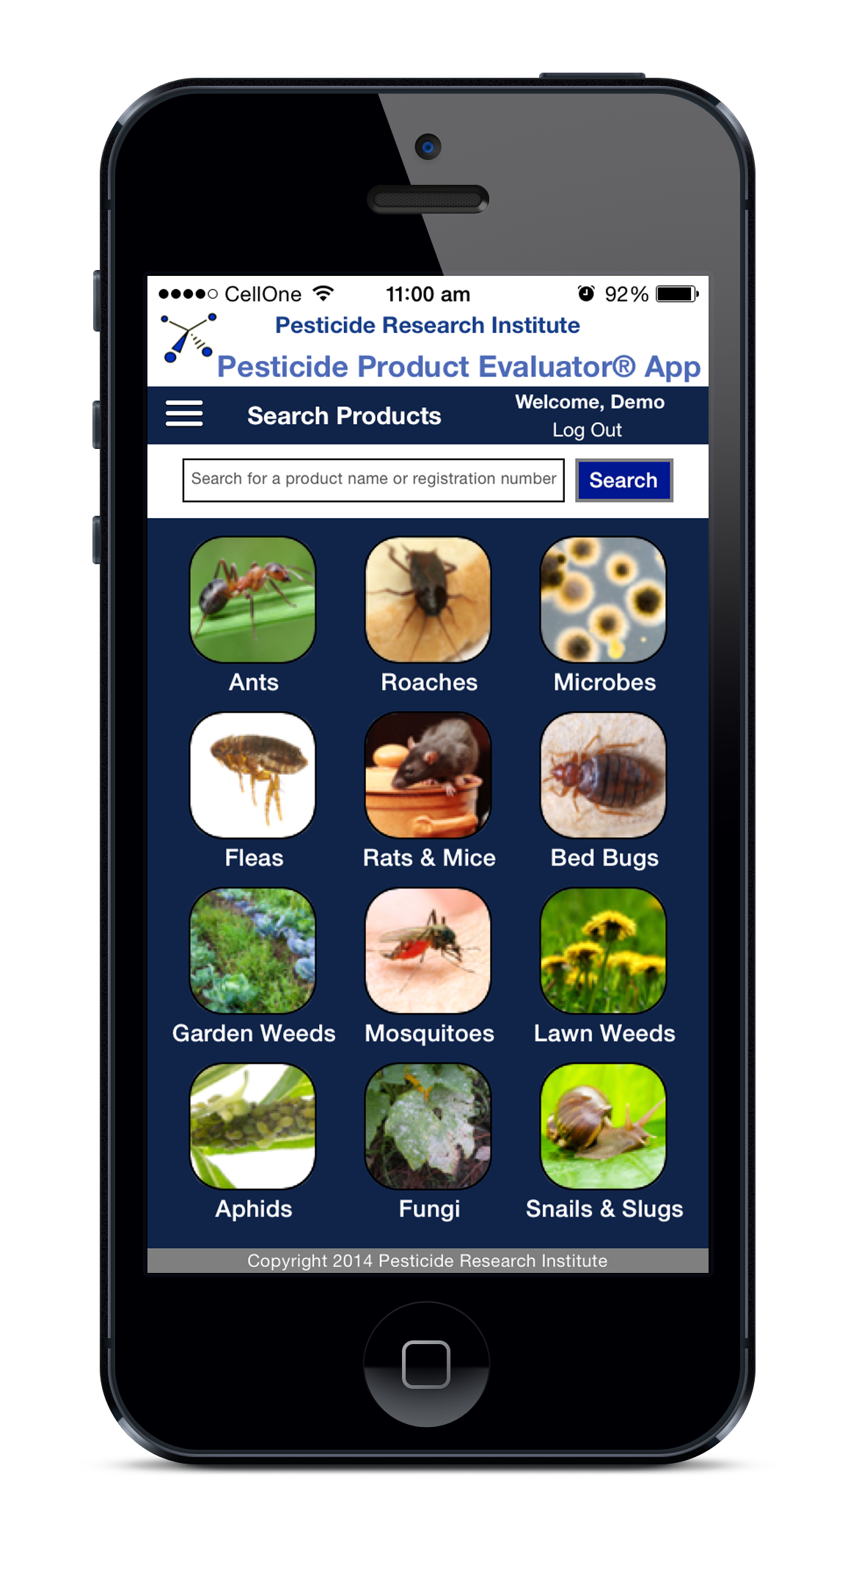

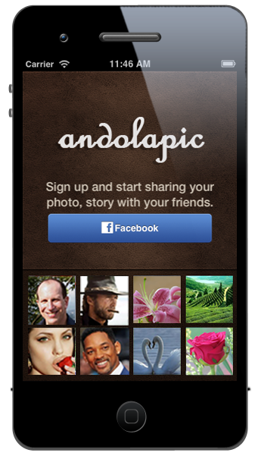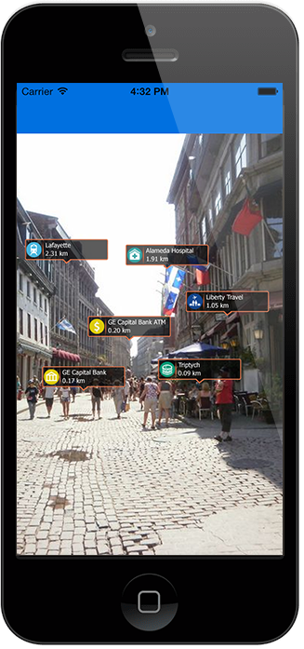

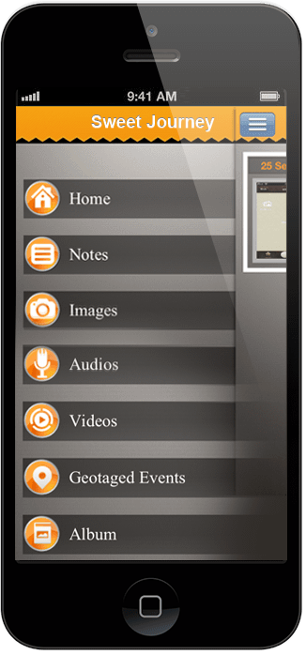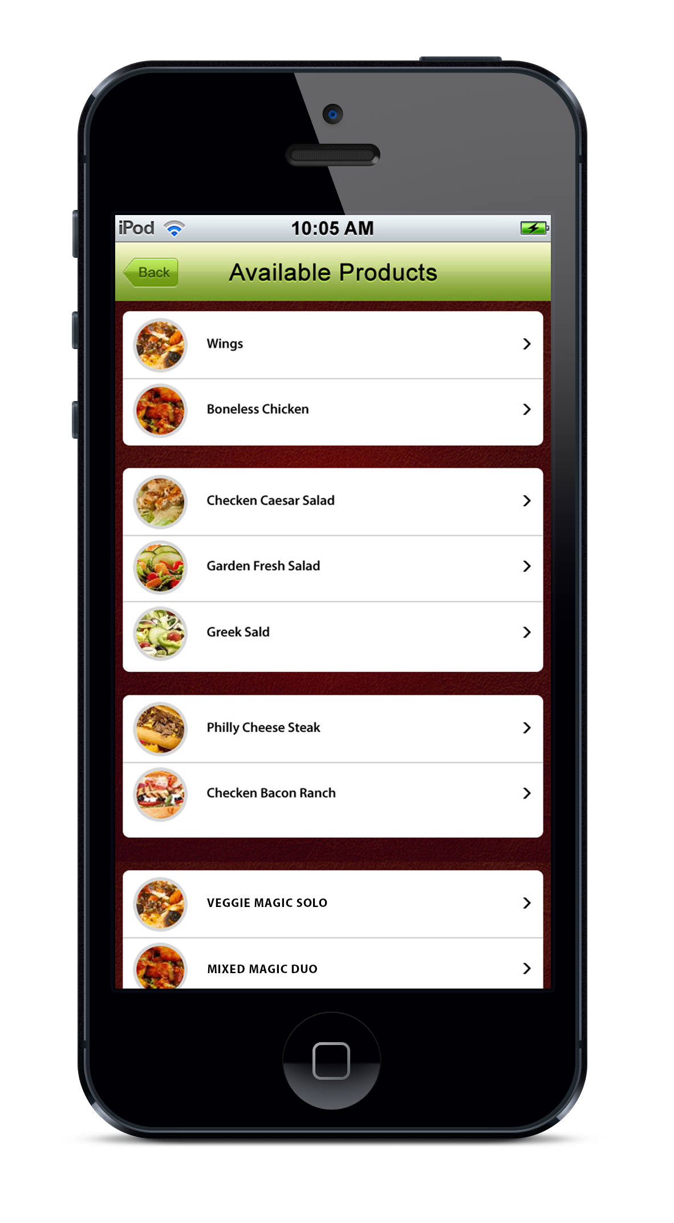

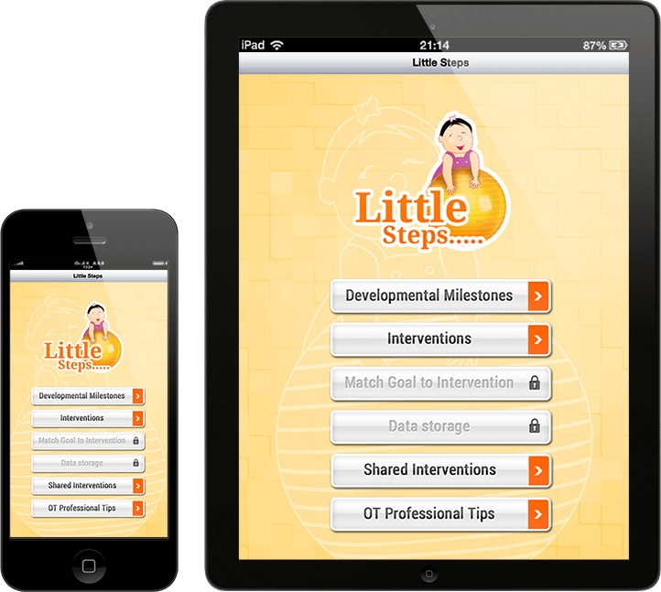

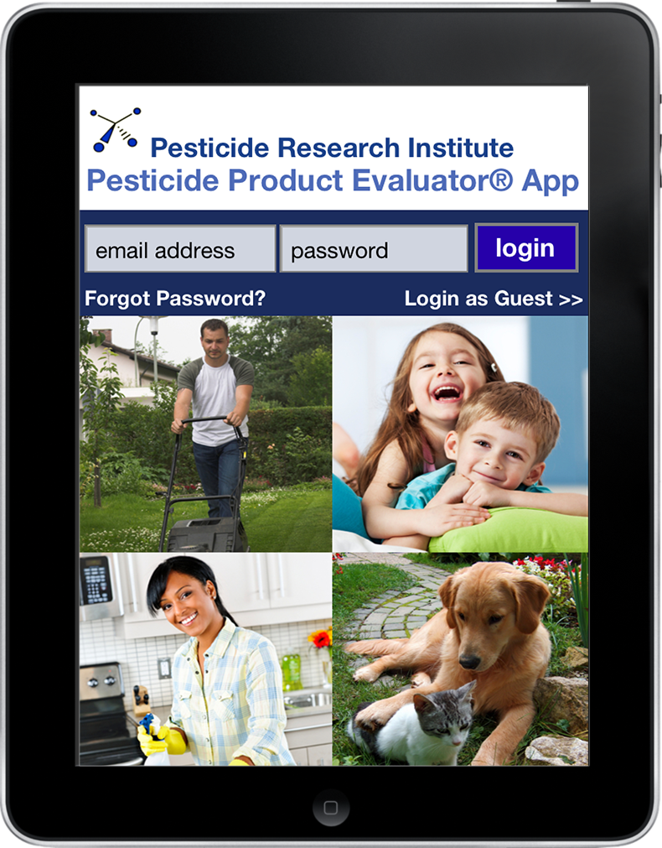

Some of our Recently Developed Android Apps

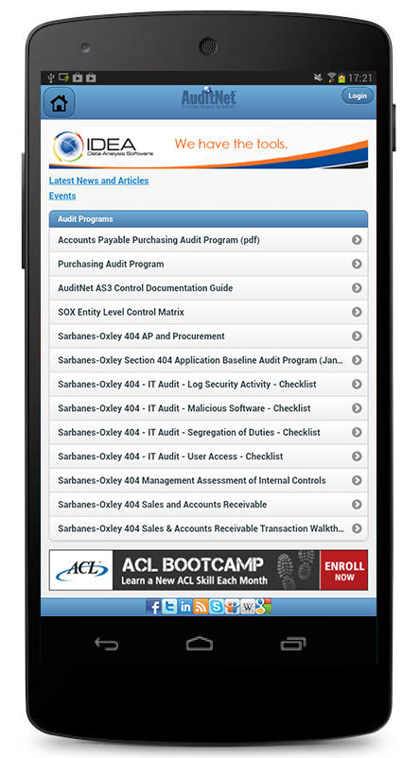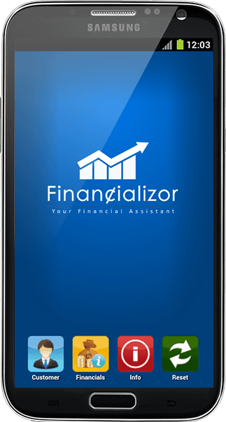

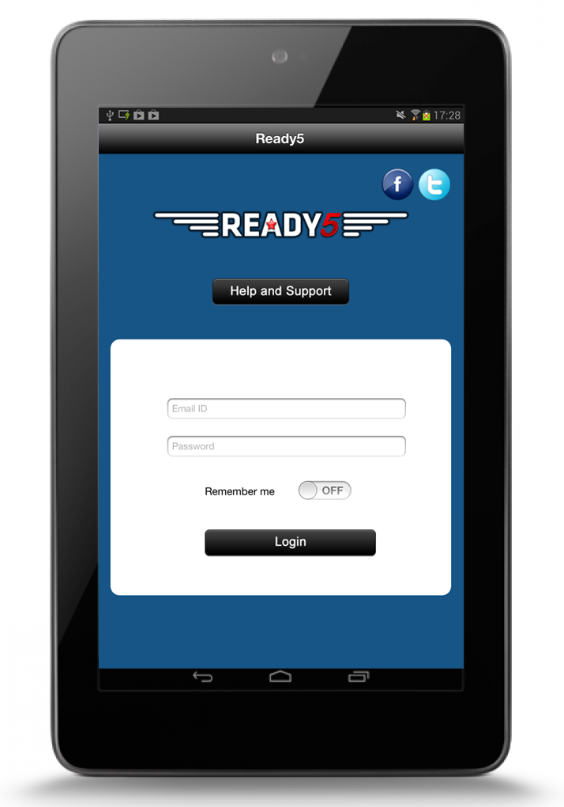

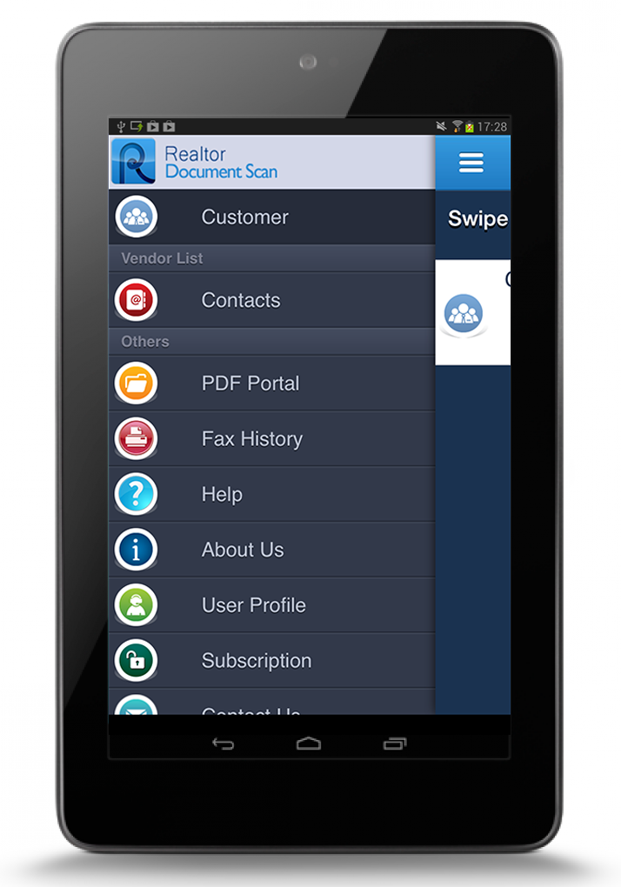

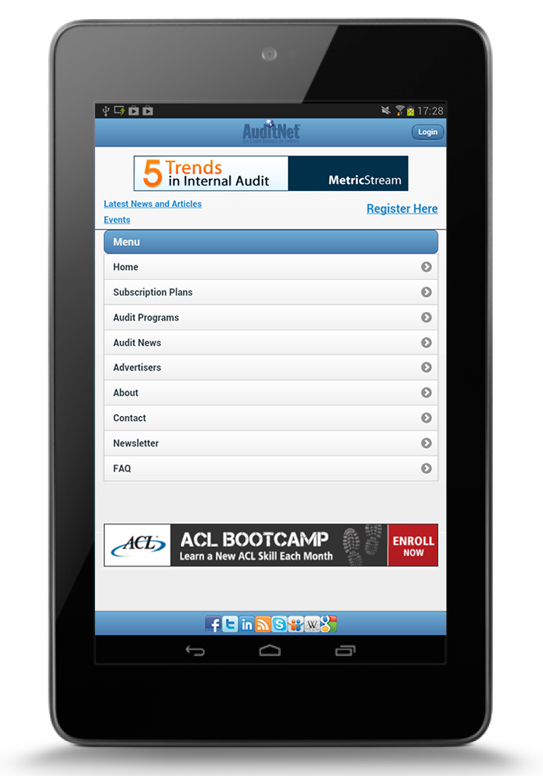

# Project scope

The specifications listed below outline the scope of work to be completed for the Mobile application. The mobile application will be developed in ***native platforms*** to run on both iOS & Android platform. The Web service api will be placed in the existing web application developed using ***Ruby on Rails*** technology.

Crm-4Beauty is already having its own web application i.e running for their own practice. Keeping in mind the growth of CRM industry, CRM-4Beauty wanted to built another platform using their own code of the existing web application. Andolasoft helped CRM-4beauty to setup the new multi tenant SAAS web application i.e currently running in heroku platform(<http://theconversiondoctor.herokuapp.com>).

Due to the growth of smartphone application usages, there is an opportunity for CRM-4Beauty to attract smartphone users looking for Customer Relationship Management. As the smartphone application would help the users to seamlessly access the core functionalities like statistics, lead management, task management...etc.

# Deliverables & Releases

We will have the following features

* Push notification settings
* Splash screen
* Login page
* Dashboard page
* Leads list
* Lead detail page
* Lead edit page
* Push notification on Lead assignment
* Role implementation
* Task list page
* Task detail page
* Task edit page
* Push notification on task assignment
* Task delete
* Task event entry on the device calendar
* App notification on the due date for upcoming task

**Release#1**

**Release#2**

**Release#3**

# Sample App Screenshots

# splash-screen.png login.png

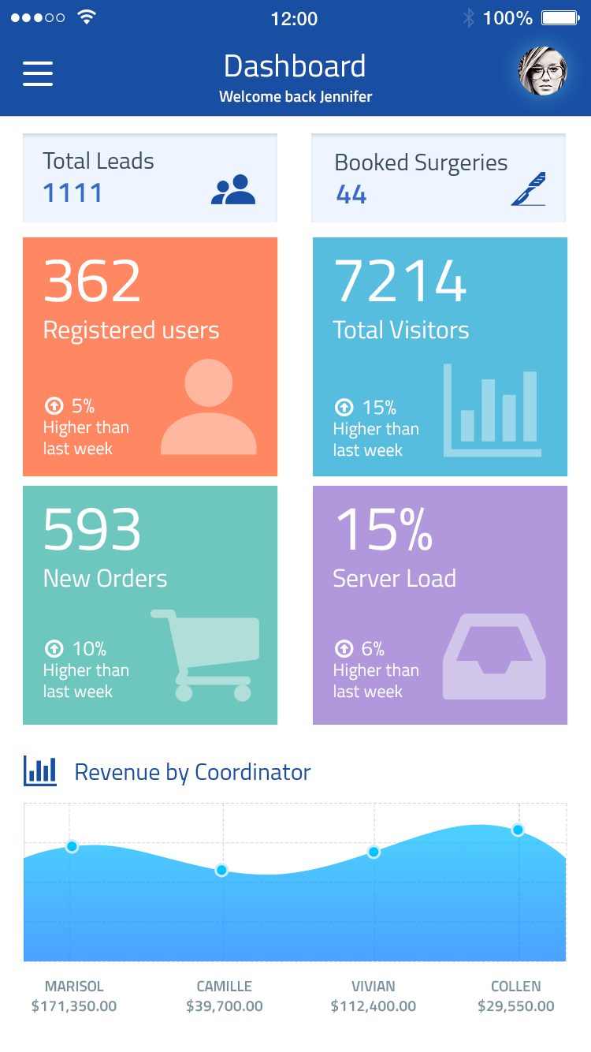 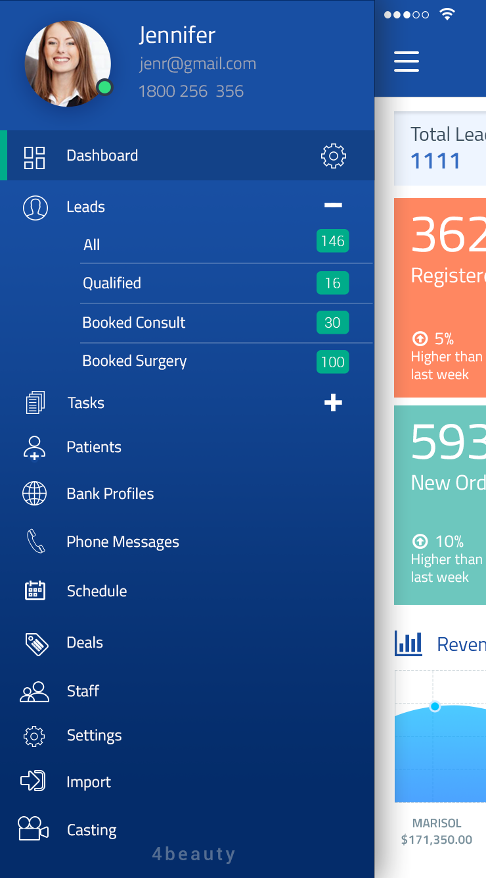

# Team structure

* Project Manager - 1
* Lead developer – 1
* Sr. developer - 2
* QA - 1
* Graphics designer for UI & UX - 1

# Project Timeline& Cost Estimation

To complete the mobile application development would take approximately 4 **weeks**of time. The pricing for the development varies depending upon the technology used to develop the mobile application as listed below

* Native (Android & iOS) - ***$9,500***

# Payment Method and Phases

|  |  |  |
| --- | --- | --- |
| Payment Milestones | % | Amount in **USD** |
| Advance on signing up the contract | 30% |  |
| On completion of the Release#1 demo | 30% |  |
| On completion of the Release#2 demo | 20% |  |
| On completion of the Release#3 demo | 20% |  |

* 30% of advance payment after signing of the contract. 30% of payment after 1st demo done for the release#1. 20% amount need to be released each time after the completion of Release#2 & Release#3 demo.
* All the payment shall be Wire Transfer to the bank detailsor through Credit Card sentthrough the invoice.
* The final instalment of the payment shall be released after completion of the mobile app development and before code handover/submitted to respective app stores

# Support & maintenance plan for mobile app

Andolasoft would like to propose for the support and maintenance plan for the developed smartphone application. Following items are covered during the support & maintenance plan.

* Responding to customer queries
* Providing Operating Systems related enhancements
* Ensuring functionality updates
* Support for New Devices
* Support for New OS
* Analytics and monthly Reporting

**Note**–The following pricings are not included on the Pricing section mentioned at Cost estimation

The monthly retainer fee for the support & maintenance plan is ***$999 per month***. There will be free support provided for 16 hours each month during the support & maintenance plan.

The hourly charges after free service is ***$30/hour***

# Change Request Process

Our technical team will analyse every change requests received from client. If the change requires significant time and effort, the same will be notified to client and appropriate effort and schedule slippage will be notified to client for approval.

# Terms & Conditions

* FREE support of 30 days would be provided by Andolasoft for any issues/defects/ to ONLY the features to be delivered as per the specification discussed in Milestone. All the cases will be created in OrangeScrum, technical team member will respond to it.
* Andolasoft would provide free support in order to publish the apps in beta/production version to the respective app stores – iOS & Android
* In order to publish the apps in respective app stores,**HICT**needsto provide respective App store credentials to Andolasoft.
* AndolaSoft would provide free support & service if any issue found during the app publishing process to iTunes& Android play store.
* However, any work unrelated to the scope originally disclosedby **CRM-4beauty** is chargeable as hourly basis. Rate will be **$30/Hour.**
* It is the sole responsibility of **CRM-4beauty** to provide legal graphical properties (free from copyright)
* Otherwise, **CRM-4beauty** can authorise Andolasoft to buy images on their behalf
* Any relevant database or API to be provided by **CRM-4beauty** on the beginning of the project.
* Feedback loop has to be closed by the **CRM-4beauty** within 24 hours in-case of weekdays & 48 hours in-case of weekends during development.

IN WITNESS WHEREOF, the parties have executed this Agreement as of the Effective Date.

**For and on behalf of AndolasoftInc:For and on behalf of CRM-4Beauty**:

By: _____________________ By: _______________________

Print Name: Priyabrata Gharai Print Name: Max Rockwell

As Its: CEO